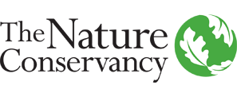 

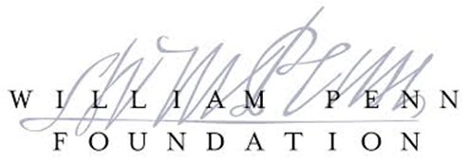

**BRANDYWINE-CHRISTINA HEALTHY WATER FUND**

**[DRAFT] BUSINESS STRATEGY PLAN**

*Prepared by*

**THE NATURE CONSERVANCY IN DELAWARE**

**AND**

**UNIVERSITY OF DELAWARE WATER RESOURCE AGENCY**

*Made possible through generous support from*

**WILLIAM PENN FOUNDATION**

**SEPTEMBER 2016**

**Contacts:**

**THE NATURE CONSERVANCY IN DELAWARE**

**100 West 10th Street, Suite 1107**

**Wilmington, DE 19801**

**Richard I.G. Jones, Esq.**

**State Director**

**Telephone: (302) 654 – 4707**

**UNIVERSITY OF DELAWARE WATER RESOURCE AGENCY**

**[ADD]**

**TABLE OF CONTENTS**

**Page**

EXECUTIVE SUMMARY 3

Overview 5

Business Strategy 6

Risk Factors 7

Sources and Uses of Funds 7

INTRODUCTION __

SITUATION ANALYSIS 8

Freshwater: A Vital Resource Under Tremendous Pressure 8

The Brandywine-Christina – An Emblematic American Watershed 8

Regulation and Management of Freshwater in the United States 10

Delegation of Authority to Pennsylvania and Delaware 10

Regulation and Management of Freshwater in the Brandywine-Christina __

Shortcomings of Freshwater Management in the Brandywine-Christina __

Business Implications of an Unhealthy Watershed 11

What is Working Well 11

OUR SOLUTION: THE BRANDYWINE-CHRISTINA HEALTHY WATER FUND 8

The Water Fund Model 8

The Brandywine-Christina Healthy Water Fund 8

Regulatory Environment 9

Watershed Management 10

The Water Fund Solution 10

Business Strategy 11

Funding Model 14

MANAGEMENT 16

Executive Officers 16

BUDGET 19

Capital Contributions 19

Fund Operations 20

Investment Accounts 21

Sources and Uses of Funds 22

DESCRIPTION OF WATER FUND UNITS 24

General 25

PLAN OF DISTRIBUTION 25

The Offer 25

Transfer Restrictions 25

RISK FACTORS 26

Development Stage Fund 26

Regulatory Risks 26

Reliance on Third Parties 27

**THE BRANDYWINE-CHRISTINA HEALTHY WATER FUND**

*“Streams and rivers provide 65 percent of America’s drinking water as well as a host of other critical services, including food production, irrigation, hygiene, hydropower and recreation. They also have been used throughout human history to carry household, agricultural, and industrial wastes downstream; and if we do not overload them, our streams and rivers are capable of processing the pollutants we discharge into them and cleaning their own waters.”*

*–* Bern Sweeney & Jamie Blain*, Reviving the Commons,* The Nature Conservancy’s “Cool Green Science” Blog, September 9, 2016

1. **EXECUTIVE SUMMARY**

**[ADD LATER]**

1. **INTRODUCTION**

The Brandywine-Christina Water Fund (“BCH Water Fund” or the “Fund”) is an innovative conservation finance mechanism designed to (a) expand the overall pool of funding for watershed-scale conservation in the Brandywine-Christina watershed, and (b) deploy capital strategically and efficiently according to a science-based protocol calculated to maximize water quality [and quantity] returns. The BCH Water Fund increases available funding by consolidating and/or coordinating investments from different constituencies with overlapping interests in improving water quality. The Fund attracts diverse sources of capital by offering (i) leverage through combined investments, (ii) a highly efficient, science-based investment protocol, and (iii) sophisticated project delivery by a collaborative team of leading conservation organizations. The ultimate goal of the BCH Water Fund is to restore the Brandywine-Christina to “swimmable, fishable, potable” status by 2030 – a goal demonstrated by our computer modeling to be realistic and achievable.

The BCH Water Fund is being developed through a partnership between The Nature Conservancy in Delaware (“TNC Delaware”) and the Water Resource Agency at the University of Delaware (“WRA”). The great majority of start-up costs to date – including a feasibility study, stakeholder outreach, refined technical and financial analysis, GIS mapping and legal and governance analysis and the development of this business plan – have been funded through a series generous grants from the William Penn Foundation as part of its Delaware River Watershed Initiative (“DRWI”). In addition, TNC Delaware and WRA have benefited from ongoing collaboration and partnership with the following preeminent local and regional conservation organizations and alliances: Brandywine Conservancy, Brandywine-Red Clay Alliance, [CTIP’s new name], Natural Lands Trust and Stroud Water Research Center .

This business plan is divided into the following sections: (1) a Situational Analysis detailing the challenges of freshwater management in the United States, and more specifically the Brandywine-Christina watershed, and the business implications of those challenges, (2) a explanation of the mechanics of the BCH Water Fund and how it will solve some of the challenges facing our watershed, and (3) [governance, financials, etc.]

1. **SITUATIONAL ANALYSIS**
2. **Freshwater: A Vital Resource Under Tremendous Pressure**

Freshwater is arguably the world’s most precious natural resource. Not only is it vital to human life and healthy functioning ecosystems; it also drives regional economies and supports a broad spectrum of business enterprises. As human populations swell, however, freshwater is under increasing and serious pressure. Diffuse contamination, primarily from urban and agricultural sources, stress our freshwater resources beyond their natural absorption capacity, rendering our waterways unable to support many forms of aquatic life and human uses. In 2016, the Environmental Protection Agency (EPA) reported that 46% of America’s rivers and streams are in “poor condition.” The EPA noted that “phosphorous, nitrogen, and streambed sentiments in particular have widespread and severe impacts,” and that “reducing levels of these constituents will significantly improve biological health of rivers and streams.” The impacts of climate change – heavy precipitation and flooding – compound the consequences of altered hydrologic systems to further compromise the ecological functionality of our waterways, soils and groundwater (e.g. filtration, natural decomposition of pollutants, buffer capacity) and create a true vicious cycle.

Unhealthy rivers and streams take a heavy toll on people and nature. Soil and other organic matter suspended in our waters not only increases filtration costs in drinking water production; they also transport harmful (even deadly) bacteria like cryptosporidium. Excess nitrogen can cause “alga blooms” in reservoirs, rendering large public water supplies unfit for human consumption. Nature struggles too: little survives in a stream is loaded with nutrients or sediments. Impaired water impacts the entire food chain – everything from small aquatic bugs to wild trout to land- and air-inhabiting creatures that depend on fish for sustenance. By contrast, employing nature-based solutions to water quality – for example, planting native trees and plants along our waterways – increases biodiversity and helps nature thrive.

Government interventions, while certainly improving the situation, provide an incomplete remedy. Beginning in the 1970s, legislation and regulation – including the creation of the EPA and adoption of the Clean Water Act – markedly improved the health of America’s waterways, but the effectiveness of those regulatory mechanisms has plateaued, due in large part to policy and enforcement bottlenecks and funding gaps. If we are to restore the power of our waterways to sustain life and beneficial human uses well into the future, we must develop new mechanisms to improve America’s water quality. Water funds – a public-private partnership model discussed in detail below – offer one of the most promising solutions.

1. **The Brandywine-Christina: An Emblematic American Watershed**

Like most rivers in the Eastern United States, the Brandywine-Christina watershed faces a complex set of challenges. The watershed spans two states (Delaware and Pennsylvania), covers more than 565 square miles, and is home to more than 590,000 people (U.S. Census 2000–2010). The majority of the land in the watershed is in Pennsylvania, while the majority of the population is in Delaware. Approximately 39% of the watershed’s land use is dedicated to agriculture, 33% is forest and wetlands, and 28% is suburban and urban (NOAA CSC 2005).

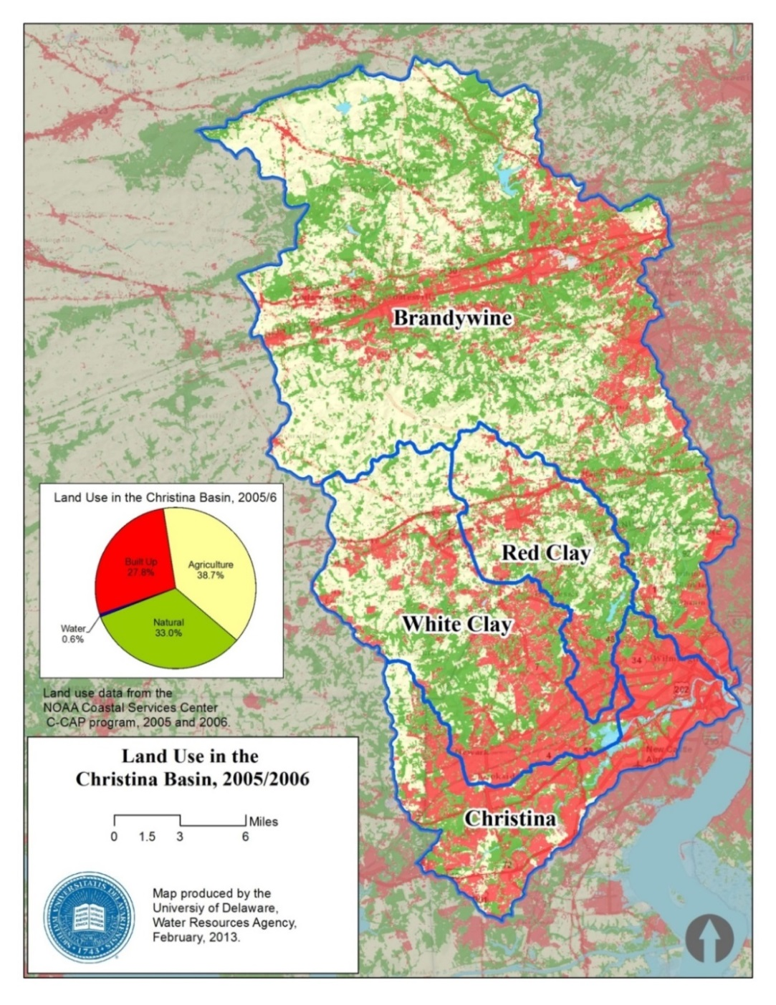

The Brandywine-Christina is comprised of four separate subwatersheds: the Brandywine, Red Clay and White Clay Creeks, and the Christina River. Two of these four subwatersheds – the Brandywine and White Clay Creeks – provide drinking water to approximately 500,000 people in the region, mostly in Delaware.

The Brandywine and White Clay Creeks are iconic American rivers. The headwaters of the Brandywine are in Honeybrook, Pennsylvania, an area reportedly named for the sweetness of its water. Honeybrook is home to an Amish and Mennonite agricultural community that produces cattle and row crops. From Honeybrook, the Brandywine flows approximately 35 miles – through picturesque open country, dense suburban sprawl and economically challenged urban zones – before reaching Wilmington Delaware, a major population center on the I-95 corridor. ***By the time the Brandywine reaches Wilmington, it is unsafe for swimming or fishing, but it nevertheless provides 100% of Wilmington’s drinking water.***

The White Clay Creek is the only American river to receive a “Wild and Scenic” designation by the United States Department of Interior for its entire length. Like the Brandywine, the White Clay begins in relatively pristine condition, but a host of intervening contaminants – mostly from agricultural and urban land cover – leaves it unsafe for fishing and swimming. The White Clay is also the primary water source for a major human populace – Newark, Delaware, home to the University of Delaware.

1. **Regulation and Management of Freshwater in the United States**

Freshwater in the United States is regulated under a Federal legislative regime that began in the 1970s with the creation of the EPA and the adoption of the Clean Water Act. The applicable regulatory framework is as follows:

* **Clean Water Act.** The Clean Water Act (CWA) is the primary federal law in the United States governing water pollution. Its objective is to restore and maintain the chemical, physical, and biological integrity of the nation's waterways by preventing or reducing point and nonpoint pollution sources, providing assistance to publicly owned wastewater treatment facilities, and maintaining the integrity of wetlands. The 1972 act introduced the National Pollutant Discharge Elimination System (NPDES), which is a permit system for regulating point sources of pollution. Point sources include: industrial facilities (e.g., manufacturing, mining, oil and gas extraction, and service industries), municipal governments and other government facilities (such as military bases), and some agricultural facilities, such as animal feedlots. Point sources may not discharge pollutants into surface waters without an NPDES permit.
* **1987 Water Quality Act**. Stormwater runoff from industrial sources, municipal storm drains, and other sources were not specifically covered by the CWA. However, Congress filled this gap with the adoption of the Water Quality Act of 1987 (WQA), which requires that industrial stormwater dischargers and municipal separate storm sewer systems (often called "MS4") obtain NPDES permits by specific deadlines. The permit exemption for agricultural discharges continued, but Congress created a nonpoint source pollution demonstration grant program at EPA to expand the research and development of nonpoint controls and management practices.
* **Safe Drinking Water Act.** The federal Safe Drinking Water Act (SDWA) is the principal federal law designed to ensure safe drinking water for the public. Pursuant to the SDWA, the EPA is required to set standards for drinking water quality and oversee all states, localities, and water suppliers who implement these standards.
* **Soil Conservation Act**. Non-point agricultural stormwater discharges and irrigation return flows are specifically exempted from permit requirements under CWA. However, in an effort to curb non-point pollution from agricultural sources, Congress authorized expanded research, technical and financial assistance programs through the United States Department of Agriculture (USDA) under the auspices of the USDA’s Natural Resources Conservation Service. Enacted in 1935, the Soil Conservation Act (SCA) recognized that "soil erosion is a menace to the national welfare and that it is hereby declared to be a policy of Congress to provide permanently for the control and prevention of soil erosion.” The SCA established the Soil Conservation Service within USDA to develop programs of soil and water conservation.In 1995, Soil Conservation Service was renamed the Natural Resources Conservation Service (NRCS) and its responsibilities and mandates were broadened.

1. **Delegation of Authority to Pennsylvania and Delaware**

In implementing the above regulatory framework, the EPA delegates its authority to state environmental protection agencies in the first instance. In the case of the Brandywine-Christina, the regulation and oversight of watershed management falls to the Pennsylvania Department of Environmental Protection (PA DEP) and the Delaware Department of Natural Resources and Environmental Control (DNREC). These Agencies, in turn, enforce regulatory requirements in their respective jurisdictions, subject to ultimate oversight by the EPA. The federal government, through the EPA, also supplies the states with low-interest financing for clean water infrastructure projects through the Clean Water State Revolving Funds, a federal-state partnership program.

Similarly, under the SCA, states were called upon to create soil conservation districts. Pennsylvania maintains a state-wide NRCS office and multiple field offices. The Chester County field office, located in West Chester, PA, has jurisdiction over state-level NRCS programs in the Brandywine-Christina, including Agricultural Management Assistance (AMA), the Conservation Stewardship Program (CSP) and the Environmental Quality Incentives Program (EQIP). In addition, at the federal and state levels, NRCS offers Conservation Innovation Grants (CIG). In 2016, NRCS invested approximately $26,6 million at the federal level to fund 40 projects.

Because state-level NRCS programs currently play a substantial role in efforts to improve water quality in the Brandywine Christina, it is important to understand how NRCS programs operate. NRCS offers voluntary programs to eligible landowners and agricultural producers to provide financial and technical assistance to help manage natural resources in a sustainable manner. Through these programs the state-level agency approves contracts to provide financial assistance to help plan and implement conservation practices that address natural resource concerns or opportunities to help save energy, improve soil, water, plant, air, animal and related resources on agricultural lands and non-industrial private forest land. The principal NRCS financial assistance programs include:

* The Agricultural Management Assistance (AMA) helps agricultural producers use conservation to manage risk and solve natural resource issues through natural resources conservation. NRCS administers the AMA conservation provisions while the Agricultural Marketing Service and the Risk Management Agency implement other provisions under AMA.
* The Conservation Stewardship Program (CSP) helps agricultural producers maintain and improve their existing conservation systems and adopt additional conservation activities to address priority resources concerns. Participants earn CSP payments for conservation performance—the higher the performance, the higher the payment.
* The Environmental Quality Incentives Program (EQIP) provides financial and technical assistance to agricultural producers in order to address natural resource concerns and deliver environmental benefits such as improved water and air quality, conserved ground and surface water, reduced soil erosion and sedimentation or improved or created wildlife habitat.
* The Water Bank Program (WBP) on the land for the benefit of migratory wildlife such as waterfowl, conserves surface waters, reduces soil and wind erosion and contributes to flood control. WBP is only available in Minnesota, North and South Dakota.

1. **Regulation and Management of Freshwater in the Brandywine-Christina**

Current watershed management approaches in the Brandywine-Christina Watershed rely on a complex system of public and private actors, further complicated by differing governance and enforcement across two states:

**[SECTION NEEDS WORK]**

1. **Stormwater Management**: Cities maintain Municipal Separate Storm, Sewer Systems to manage munitipal stormwater (MS4.) An MS4 is a conveyance of a system of conveyances that is (a) owned by a state, city, town, village or other public entity that discharges to waters of the commonwealth and (b) designed to collect or convey stormwater. Under current regulatory parameters set forth in the 1987 Water Quality Act, MS4 systems require an NPDES permit. MS4 compliance by regulated entities such as counties, cities, towns, universities and transportation departments, is funded through taxes and fees levied at various levels of government. Because permit holders can only be compelled to act within their jurisdictional boundaries, MS4 investments are often directed toward expensive solutions that have little impact on the overarching hydrologic system. Thus, MS4 management continues to present challenges for both environmental protection agencies (state and federal) and regulated entities.
2. **Watershed Pollution Management**. Point source pollutants encompass the discharge of waste through pipes, typically by industrial and commercial concerns. Under the CWA, Total Maximum Daily Load (TMDL) describes a value of the maximum amount of a pollutant that a body of water can receive while still meeting water quality standards. To enforce TMDLs with point sources pollutants, water quality-based effluent limitations must be developed and incorporated into discharge permits for these sources. The permits are issued by EPA and state agencies under the National Pollutant Discharge Elimination System (NPDES). *Funding for NPDES compliance comes from private entities, and regulatory compliance tends to strictly reduce pollutants. This approach has had significantly reduced point source pollution in America’s waterways and continues to represent an effective pollution reduction approach.*
3. **Nonpoint Source Pollutant Management**. Non-point source discharges describe pollutants that discharge into waterways from disparate sources, such as agriculture or industrial run-off. Non-point source pollutants are generally reduced in a voluntary compliance scenario. The TMDL implementation plan is intended to help bridge the divide and ensure that watershed beneficial uses are restored and maintained. Local watershed groups play a critical role in educating stakeholders, generating funding, and implementing projects to reduce nonpoint sources of pollution. *Funding for nonpoint source solutions has historically come from the Federal Government/Natural Resource Conservation Service (through State Conservation Districts) and through local conservation organizations funded by philanthropic sources. Significant opportunities exist to rationalize and enhance investment in nonpoint source pollutant management.*
4. **Drinking Water Management.** Drinking water supplies are typically managed by public agencies (Departments of Public Works) or private entities who are licenses by state jurisdictions to receive water from ground or surface sources, process water and deliver water to end users through. The centralized drinking water supply infrastructure in the United States consists of dams and reservoirs, well fields, pumping stations, aqueducts for the transport of large quantities of water over long distances, water treatment plants, reservoirs in the distribution system (including water towers). *Funding for drinking water regulatory compliance comes from operating investments made by public or private suppliers who generate revenue and operating capital from the sale of potable drinking water to end users.*

Since implementation of the CWA, the 1987 WQA and the SDWA, water quality in America’s waterways, and in the Brandywine-Christina watershed has improved – in large part due to dramatic reduction in point-source (industrial and commercial) pollution discharge. Nevertheless, a great majority of rivers and streams remain impaired under CWA Standards. This ongoing impairment relates primarily to excess nutrient loads and excess sediment loads, which in turn derive mainly from non-point-source pollution such as agricultural and urban run-off.

1. **Shortcomings of Freshwater Management in the Brandywine-Christina**

The current system of watershed management across the Brandywine-Christina Watershed faces three critical challenges:

**[NEEDS WORK]**

***Limited implementation of non-point-source pollution interventions. [****Explain why these interventions haven’t happened].* Non-point source pollutants are not directly regulated by any of the major legislation that governs point source pollutants or clean drinking water. Accordingly, the development and implementation of best management practices (BMPs) for non-point source pollutants such as agricultural and infrastructure run-off has dramatically trailed that of point source pollutants. Further, lack of economic incentives for agricultural producers and other property owners and managers to improve BMPs undermines investment rationale, and lack of funding – despite promising potential environmental outcomes - plagues further investment.

***Fractured and ineffective MS4 planning and implementation. [****Explain why MS4 interventions haven’t happened or have been hampered].* The current system of MS4 planning and implementation is fraught with challenges based on geographic **constraints**, lack of coordination among adjacent jurisdictions, and limited tax and fee revenue generation capacity. Many MS4 plans have failed to achieve approval by regulatory authorities, and even when approved many have not achieved full funding or effective operation.

***Fragmented conservation solutions.*** *[Explain fragmentation of approach.]*The current clean water regulatory environment often drives immediate, limited solutions that do not address larger watershed-wide issues and objectives. Over-lapping stakeholder groups and lack of clear accountability measures create a “tragedy of the commons” situation in which no one claims responsibility for problems or holds themselves accountable for solutions. This fragmented environment makes problem solving at scale challenging, and undermines conservation innovation.

1. **The Business Implications of an Unhealthy Watershed.**
2. **The Drinking Water Business in the Brandywine-Christina**

Approximately 500,000 people depend on the rivers of the Brandywine-Christina watershed for their drinking water. In Delaware, three entities withdraw surface water from the Brandywine-Christina for processing and sale to the public as drinking water (we refer to such entities as “water companies”). Two of these water companies – the City of Wilmington and the City of Newark – are public municipalities. The third water company, Suez Water Delaware, Inc. (formerly United Water Delaware), is a subsidiary of the world’s second largest water company, Suez Environment. Wilmington withdraws approximately 20 million gallons [per year?] from the Brandywine Creek. Suez and Newark respectively withdraw approximately 20 and 2 million gallons [per year?] from the White Clay Creek. Several Pennsylvania drinking water companies – including Aqua America and Aqua PA – draw approximately 10 million gallons combined from the Brandywine each year to supply their customers with drinking water.

Because they serve a public necessity, non-municipal water companies like Suez, Aqua America and Aqua PA are considered quasi-public entities or “public service corporations”. As such, their rate setting is scrutinized by public oversight bodies. Rates increases sought by Suez are approved by the Delaware Public Service Commission (PSC). The Pennsylvania Public Utility Commission (PUC) oversees rate setting by Aqua American and Aqua PA.

**[DEVELOP CASE FOR WATER PURVEYOR INVESTMENT – INCLUDING LOWER RISK OF CATASTROPHIC EVENTS AND REDUCED PRODUCTION COSTS]**

1. **The Agriculture Industry in the Brandywine Christina**

The agriculture industry in the Brandywine-Christina is representative of a vital and threatened sector in American farming: small family farms (between 50 to 250 acres) struggling to maintain viable businesses in close proximity (100 miles) to a major metropolitan center. In the aggregate, small farms account for approximately __ % of America’s diary and meat production and approximately __% of the total number of American farms. They also provide the economic foundation for many rural communities, fueling a host of ancillary businesses like construction, trucking, insurance and sales of farming equipment and supplies.

Farming in the Brandywine-Christina divides into two major categories: crops and livestock. Crops – mostly corn and alfalfa – are primarily grown as feed for cattle being raised on the farm. Cattle are further divided into two uses – diary and beef. Chester County, a major portion of which includes the Brandywine-Christina basin, produces approximately 45 million gallons of milk annually. [Meat?] [note that it is mostly poultry, and other forms of agriculture (e.g., nurseries and greenhouses) generate far more revenue - <https://www.agcensus.usda.gov/Publications/2012/Online_Resources/County_Profiles/Pennsylvania/cp42029.pdf>]

Numerous challenges face small family farmers in close proximity to major urban areas. First, margins on beef and milk (the primary commodity) are under pressure, due in large part to consolidation in the agriculture industry around large industrial farms and a resulting compression in commodities pricing. Second, a majority of small farms are on the cusp of being passed to the next generation, many members of whom are not interested in being in the farming business. Third, suburban sprawl presents an increasingly tempting alternative to farming – sell the family farm to housing developers.

[Wawa hasn’t owned cows since the 1940s, but the dairy plant processes about 100,000 gallons of milk a week, much of it from Pennsylvania’s Amish farms, to serve stores and 903 wholesale accounts (such as a prison supplier and Villanova University).  
Read more at <http://www.phillymag.com/articles/wawa-world/#BDDJgwcJtr28Fs32.99>]

**[EXPLAIN UNSUSTAINABILITY OF CURRENT AG PRACTICES, NRCS AND RURAL DEVELOPMENT POTENTIAL AND POSSIBLE BUSINESS UPLIFT FROM DEVELOPING MARKET FOR LOCAL SUSTAINABLY PRODUCED PRODUCTS]**

1. **Stormwater Management in the Brandywine-Christina**

**[EXPLAIN CURRENT PERMITTING SITATION, SHORTCOMINGS AND POTENTIAL SOLUTIONS]**

1. **Recreation and Public Demand for Clean Water**

**[ADD UD STATS ON ECONOMIC BENEFITS OF HEALTHY B-C; ALSO SUMMARIZE OPINION WORKS RESULTS]**

1. **What is Working Well**

**[ADD POSITIVES, INCLUDING WPF’S DRWI; NGO FACILITATION OF NRCS AND RURAL DEVELOPMENT PROGRAMS; STATE- AND COUNTY- LEVEL PROGRAMS LIKE GROWING GREENER; WILMINGTON, NEWARK and SUEZ SOURCE WATER PROTECTION, CTIP/CWP, SUCCESSFUL WATER FUNDS ELSEWHERE (SEE CASE STUDY IN FEASIBILITY STUDY, WHICH NEEDS UPDATING)]**

**IV. OUR SOLUTION: THE BRANDYWINE-CHRISTINA HEALTHY WATER FUND**

1. **The Water Fund Model**

In its most basic terms, a water fund is a financial vehicle through which downstream beneficiaries of freshwater invest in upstream conservation measures designed to return water quality benefits. The following graphic illustrates how the model functions:

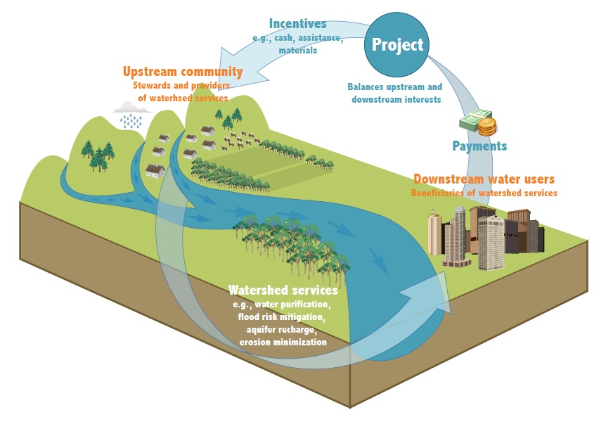

Water funds were pioneered in Latin American over the last decade or so by The Nature Conservancy and its partners. They are now being deployed around the world, with prominent examples cropping up in Australia, Africa, China and various North American locations. Most existing water funds deal with relatively simple watersheds, where the geography is narrowly drawn, the water quality threats are not complex and there is a direct causal link between the threat and the investor’s business interests.

1. **The Brandywine-Christina Healthy Water Fund**

The BCH Water Fund represents one of the first attempts to apply the water fund model in a complex urbanized American watershed. That does not mean that the requisite factors – downstream beneficiaries with a financial interest in improved water quality; upstream water-quality stressors that lend themselves to conservation solutions – are not present in the Brandywine-Christina; they most certainly are. However, they are more complicated and require a more complex (but by no means impossible) solution.

The BCH Water Fund offers that solution through an innovative conservation finance mechanism designed to address current gaps and promote practical solutions within the watershed management system, thereby dramatically improving water quality across the Brandywine-Christina watershed on an accelerated basis. The Fund will achieve this objective by employing the following three-stage strategies:

**[NEEDS ADJUSTING DEPENDING ON CONTENT]**

1. **Fund Launch: Modest Drinking Water Investments**

**[DESCRIBE STRATEGY – WATER PURVEYOR INVESTMENTS MATCHED BY PHILANTHROPIC CAPITAL – INVESTMENT STRATEGY TARGETED TO GREATEST CONCERNS – ENGAGEMENT PROCESS TO DATE AND SOFT COMMITMENTS (COULD REALLY USE LETTERS OF SUPPORT)**

The Fund targets Water Purveyors (public and private drinking water suppliers) as the priority leading capital provider for non-point source interventions. [Economic analysis related to return on investment in watershed BMPs, willingness of water purveyors to invest, etc.]

Target Companies include:

<http://www.dnrec.delaware.gov/wr/Services/Pages/WaterSupply.aspx>

[https://www.google.com/webhp?sourceid=chrome-instant&ion=1&espv=2&ie=UTF-8#q=delaware+water+utilities&rflfq=1&rlha=0&rllag=39422286,-75566343,30218&tbm=lcl&tbs=lf:1,lf_ui:2](https://www.google.com/webhp?sourceid=chrome-instant&ion=1&espv=2&ie=UTF-8)

[https://www.google.com/webhp?sourceid=chrome-instant&ion=1&espv=2&ie=UTF-8#q=water+contractors+in+pennsylvania&rflfq=1&rlha=0&rllag=40107190,-77624387,195938&tbm=lcl&tbs=lf:1,lf_ui:2](https://www.google.com/webhp?sourceid=chrome-instant&ion=1&espv=2&ie=UTF-8)

* 1. Suez Water (formerly United Water Delaware). <https://www.suez-na.com/>
  2. City of Wilmington Department of Public Works. <http://www.ci.wilmington.de.us/government/city-departments/department-of-public-works/clean-waterways-wilmington>
  3. City of Newark Water Department. <http://www.cityofnewarkde.us/>
  4. Pennsylvania American Water Co. <http://www.amwater.com/paaw/>
  5. Aqua America - <https://www.aquaamerica.com/our-states/pennsylvania.aspx>

1. **Expand Investments in Water Quality Conservation**

The Fund’s capitalization model will align and consolidate key watershed stakeholders and clean watershed beneficiaries into an orchestrated investment mechanism that maximizes strategic and operational inputs and drives economic efficiencies and rapid innovation.

**[ADJUST GRAPHIC TO FIT FUNDING SEQUENCE]**

***[Explain strategic funding approach and rationale with main funding partners]***

**1. National Resources Conservation Service and USDA Rural Development.**

*[Explain funding from NRCS, approach, timing, limitations, etc.]*

NRCS offers voluntary programs to eligible landowners and agricultural producers to provide financial and technical assistance to help manage natural resources in a sustainable manner. Through these programs the agency approves contracts to provide financial assistance to help plan and implement conservation practices that address natural resource concerns or opportunities to help save energy, improve soil, water, plant, air, animal and related resources on agricultural lands and non-industrial private forest land. Main financial assistance programs include:

* The Agricultural Management Assistance (AMA) helps agricultural producers use conservation to manage risk and solve natural resource issues through natural resources conservation. NRCS administers the AMA conservation provisions while the Agricultural Marketing Service and the Risk Management Agency implement other provisions under AMA.
* The Conservation Stewardship Program (CSP) helps agricultural producers maintain and improve their existing conservation systems and adopt additional conservation activities to address priority resources concerns. Participants earn CSP payments for conservation performance—the higher the performance, the higher the payment.
* The Environmental Quality Incentives Program (EQIP) provides financial and technical assistance to agricultural producers in order to address natural resource concerns and deliver environmental benefits such as improved water and air quality, conserved ground and surface water, reduced soil erosion and sedimentation or improved or created wildlife habitat.
* The Water Bank Program (WBP) on the land for the benefit of migratory wildlife such as waterfowl, conserves surface waters, reduces soil and wind erosion and contributes to flood control. WBP is only available in Minnesota, North and South Dakota.

# Municipal Governments

MS4 strategies will focus on rationalizing existing plans and budgets for MS4 solutions in the Brandywine-Christina watershed. The Fund has identified several key municipal partners with strong interest in advancing a collective MS4 strategy:

###### Municipality #1

###### Municipality #2

###### Municipality #3

###### Municipality #4

###### Municipality #5

# Pay for Performance

# Corporate & Community Stakeholders [WAWA, Dow/DuPont, CSC, Banks, Developers, Etc.

# Potential Mitigation Bank/Credit Sales

# II. Water Fund Investment Strategy:

# [CONCLUSIONS FROM MODELING AND TECHNICAL ANALYSIS]

# [INITIAL FOCUS AREAS AND INVESTMENT STRATEGIES – INCENTIVIZING AG BMPs AND SUSTAINABLE AG BUSINESS THROUGH REVOLVING LOANS, EXPEDITED TECHNICAL ASSISTANCE AND NRCS APPROVAL AND MARKET-BASED PREMIUMS]

**III. Fund Development to Date:**

***[Fill in approach – UD studies, research, graphics – modelling, mapping, stakeholder outreach, etc. DESCRIBE IN DETAIL WORK YOU HAVE DONE TO DATE, AND HOW YOU WILL ADVANCE ON A SCIENTIFIC/ECOLOGICAL BASIS]***

The Nature Conservancy and University of Delaware’s Water Resource Agency, with funding from the William Penn Foundation, spent the last 2 years completing comprehensive research and analysis around watershed management approaches, and feasibility studies for the Brandywine-Christina watershed. This research has yielded compelling and clear directives for the types of investments required to generate the best environmental outcomes, the approach required to generate maximum environmental return on investment, key strategic and tactical components to a tight implementation plan, and organizational priorities that should guide the Fund’s work.

Feasibility studies and scientific protocol analysis has identified the priority objectives and strategies for the Fund’s work:

**[NEEDS ADJUSTMENTS]**

The process of removing impairments to waterways focuses primarily on non-point source pollutants and related interventions. These BMP’s include:

* Agricultural mitigation – nutrient management plans, cover crops, livestock fencing
* Riparian Buffers – protection and restoration
* Forest preservation and reforestation
* Farmland preservation – fee and easements acquisition
* Open space preservation – fee and easement acquisition
* Headwater preservation – fee and easements acquisition
* Streambank restoration and stabilization
* Wetland/floodplain restoration and reconnection

Approaches to maximize efficiency of MS4 operations include:

* Multi-municipality approach to MS4 planning and implementation
* Stormwater retrofits in urban areas
* Stormwater runoff reduction to mitigation flooding, erosion and sedimentation
* Increased tree canopy in urban/suburban areas

# Implementation Plan

# [WATER PURVEYOR INVESTMENTS MATCHED BY WPF]

# [INTIAL PROJECT PORTFOLIO BASED UPON MODELING AND TECHNICAL ANALYSIS; WHOLE-FARM BMP INCENTIVES; MONITORING AND ADAPTIVE MANAGEMENT]

# [APPLY FOR NRCS INNOVATION AND/OR RURAL DEVELOPMENT GRANTS - NATIONAL]

# [MS4 COORDINATION IN PA AND DE]

# [DEVELOPMENT OF POTENTIAL P-F-P PILOT TYING IN SRF FUNDS]

# [CORPORATE SUPPLY CHAIN SUSTAINABILITY; COMMUNITY DEVELOPMENT]

# [DEVELOPMENT OF POTENTIAL MITIGATION BANK/CREDIT CAPTURE]

# [COMMUNICATIONS, BRANDING AND MARKETING PLAN]

# Conclusion

# MANAGEMENT TEAM

# BUDGET